# Flight Information System

## 1. Project Description

This project is a Java-based application for managing airline flight information. The system allows users to input details for multiple flights via a console interface. The entered data is validated, stored, and can be displayed in a sortable, filterable Graphical User Interface(GUI) built with Java Swing.

The core purpose of this project is to demonstrate fundamental OOP (object-oriented programming) principles, including class design, encapsulation, inheritance, and the application of design pattern Model-View-Controller (MVC).

## 2. Key Features

* Console Data Entry: Using console for inputting detailed flight information
* Validation: Create utils class for validation
* Sorting:
  + The console application provides a menu to sort flights by various options
  + The GUI allows dynamic sorting and filtering of flight data
* In-Memory Data storage: Using FlightController to manage a list of flight objects during runtime.
* GUI: built with Java Swing to display flight data in a structured table
* MVC Architecture: The project is structured using the Model-View-Controller pattern to separate data logic, user interface and control flow

## 3. Technologies and Tools Used

* Language: Java
* GUI: Java Swing
* IDE: IntelliJ IDEA

## 4. Installation and Setup

### Prerequisites

* Install JDK latest version

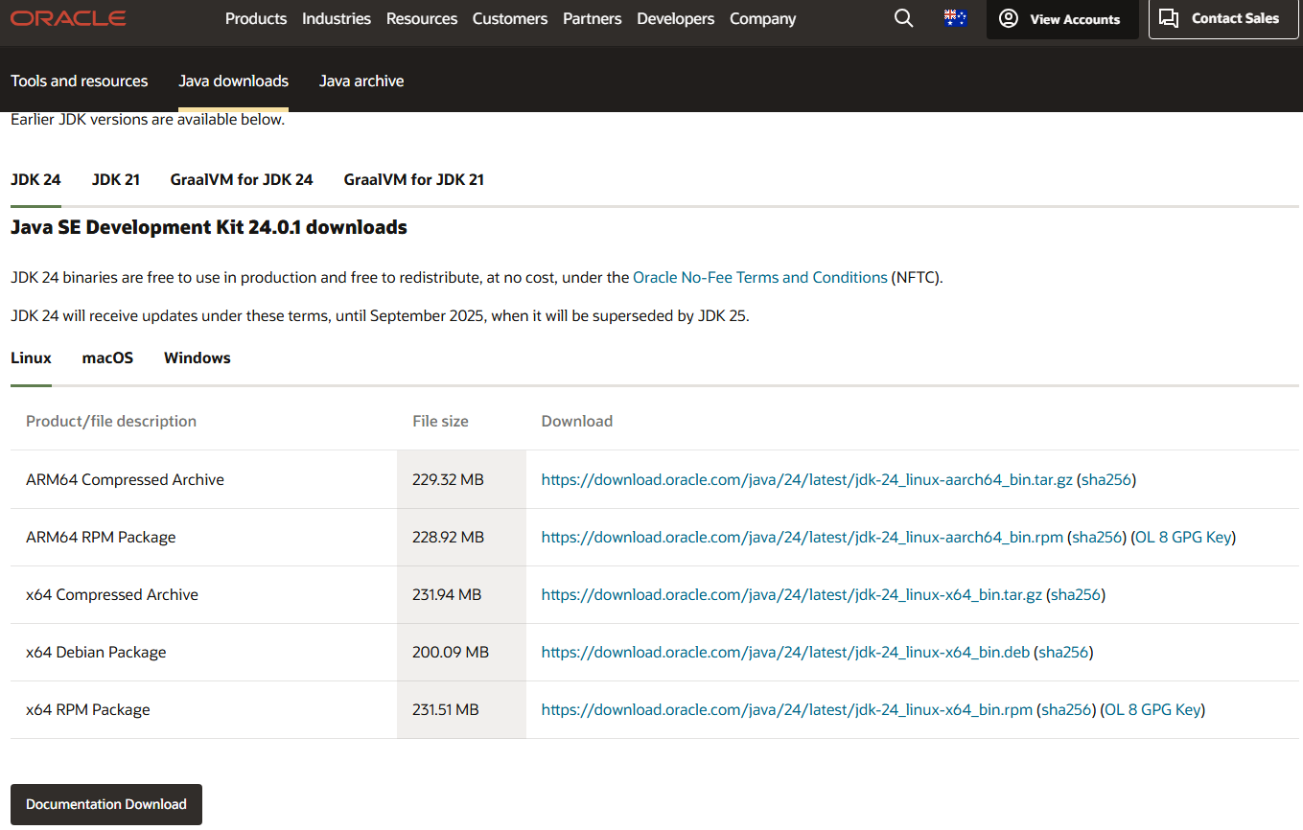

* Install IntelliJ IDEA

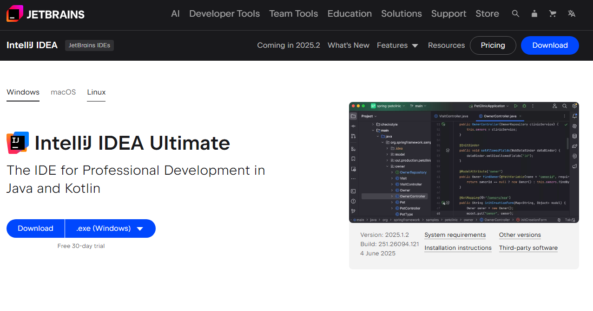

## 5. Usage instructions

You can run the application from flightapp directory

* Execute the main application using SHIFT + F10



- The program will first launch the console interface. Follow the on-screen prompts to enter flight details

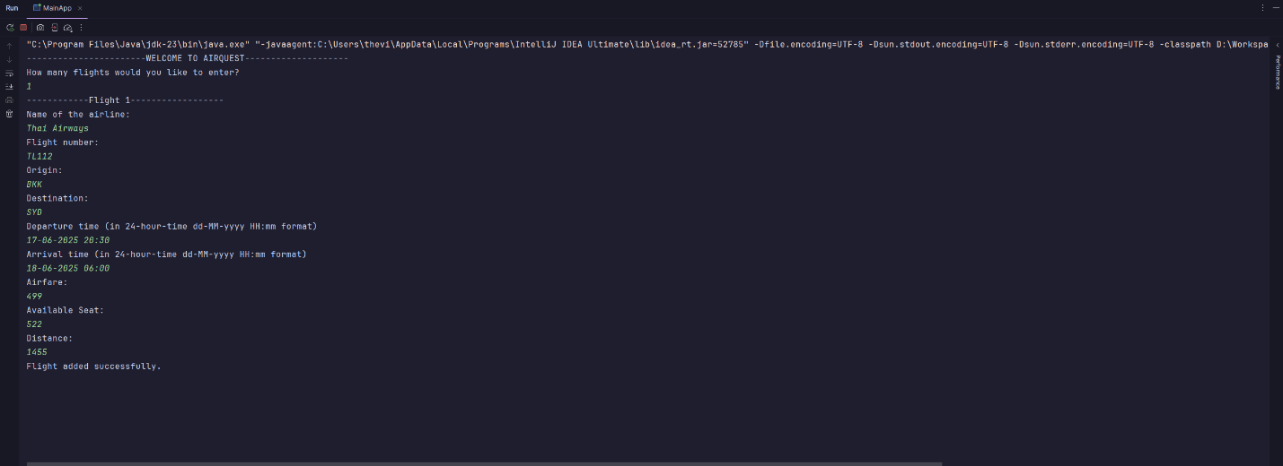

- After all data has been entered via the console, the GUI window will automatically appear, display the data you just entered.

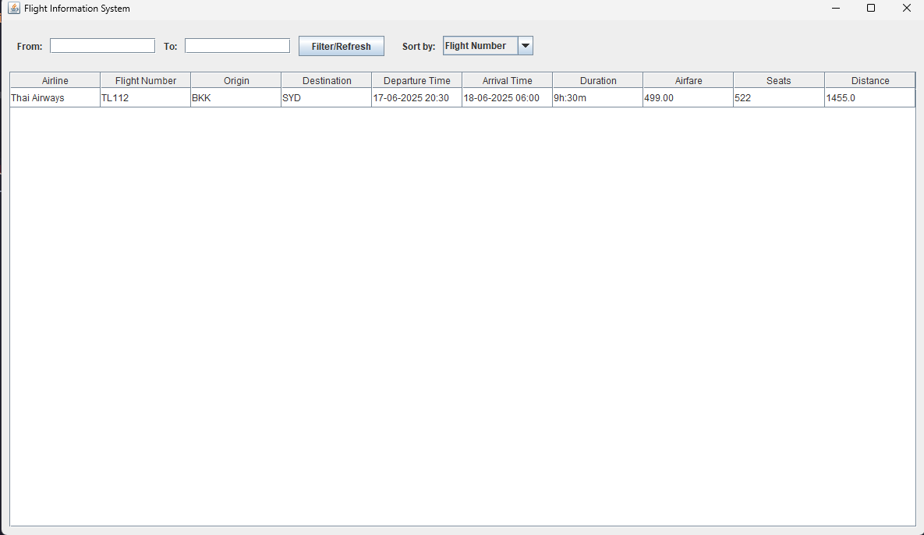

* You can use the GUI to sort and filter the flight information.

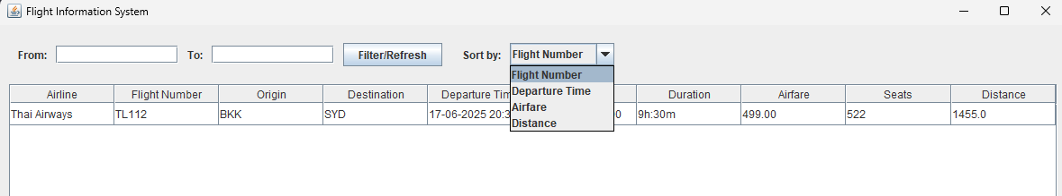

## 6. UML Diagram

